# How to use ODBC Connect

ODBC Connect allows you to connect to 32bit and 64bit ODBC data sources. It has a number of features that assist with TM1 development:

* Display tables, views and columns in a database
* Create SQL statements by dragging a table on to the query editor
* View database result in a grid
* Import 32bit sources into a 64bit system through command line arguments and ExecuteCommand
* Export data to file
* Copy data from the results window
* Give meaningful error descriptions
* Execute SQL using the same driver that is used in TM1

## Connecting to a Database

1. First configured a System DSN using the ODBC Administrator.
2. Use the correct version depending on whether you are accessing a 32bit or 64bit ODBC data source.

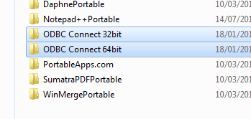

1. Select the DSN from the data source drop down on the toolbar  
     
   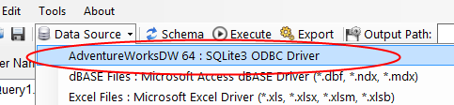
2. Enter a user name and password into the boxes provided.  
     
   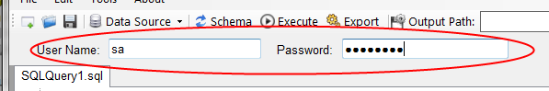
3. Press the Schema button to load the tables in the left hand pane.  
     
   

## Building SQL Statements

### Full SQL Select Statement

You can easily build SQL statements by dragging a Table from the left hand pane to the query editor.

1. Click and hold the table name  
     
    
2. Drag to the right-hand query editor  
     
   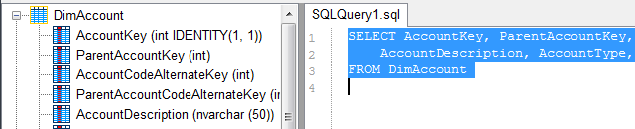

### Table and Column Names

You can insert the names of tables or columns by double-clicking the name in the schema explorer. These will then be inserted into the query window.

## Using ODBC Connect as a Data Source in TM1

You can use ODBC Connect as a data source when you don’t have access to a 64bit ODBC driver or the 64bit ODBC driver doesn’t work with TM1.

ODBC works by loading data through the ODBC connection and then saving it to a CSV file that can be imported into TM1 as required.

To setup ODBC Connect for a 32bit ODBC setting following these steps:

1. First install the 32bit ODBC driver on the server
2. Setup a System DSN using the 32bit ODBC Admin tool, note the directory is C:\Windows\SysWOW64. You can’t use the one in the Control Panel which is for 64bit ODBC drivers only.  
     
   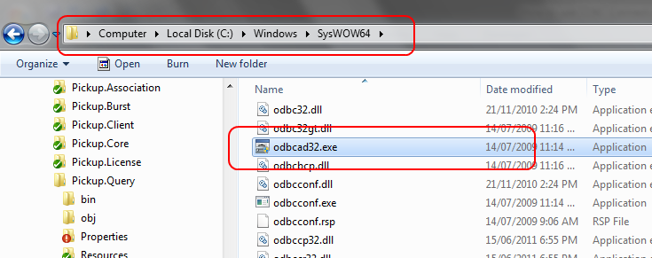  
     
   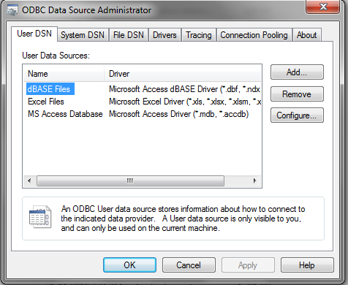
3. Save the ODBC Connect program folder on to the server, use a path that is short, something like: C:\ImportFiles\ODBC Connect 32bit\
4. Open the 32 bit version of ODBC Connect
5. Select the ODBC DSN has shown in the section above and enter the User Name and Password
6. Enter the SQL statement that you would like to Execute in the Editor  
     
   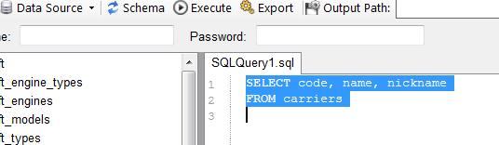
7. Enter the path you want to export the data to, this path will be reused so make sure you have a unique name for each SQL statement.  
     
   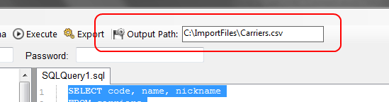
8. Click on the Export button, this will create the file you can use as the source for your TI process.
9. Create a new Turbo Integrator process with Text as Datasource Type and select the file you just created with the Export button.  
     
   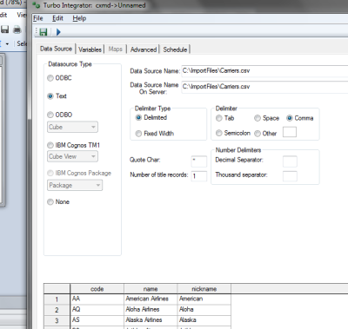
10. Go to the Tools menu and choose Copy TM1 Command to Clipboard or Copy TM1 Command to Clipboard (Encypted). The second option encrypts the password.   
      
    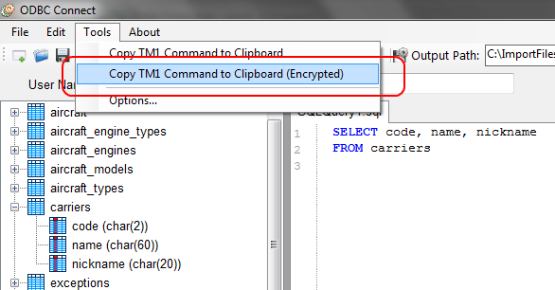
11. Go to the Prolog of the process you created and paste the command into the TI editor.  
      
    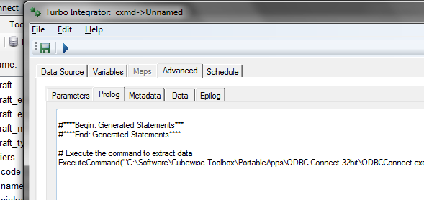
12. You can know update the TI process as required. Each time the process is run the SQL will be executed and a new CSV file created.